PORTFOLIO PROJECT



**Duc Tran Greenwell, Amber Sahota, Sam Warutere**

09.13.21

FIN810

**Table of Contents**

**MACRO ECONOMY AND INVESTMENT STRATEGY** **2**

Macroeconomic Analysis 2

Strategy Description 3

Company Analysis 4

**STOCK AND MARKET PERFORMANCE ANALYSIS** **5**

Daily Stock Statistics 5

Capital Asset Pricing Model (CAPM) 6

Fama-French 3 Factor Model 7

Sharpe Ratio 7

Safety First Ratio 8

Ranking 8

**PORTFOLIO OPTIMIZATION**9

Optimum Portfolio & Asset Allocations 9

**REFLECTION & FINAL THOUGHTS** **9**

**APPENDIX** **10**

# MACRO ECONOMY AND INVESTMENT STRATEGY

## Macroeconomic Analysis

The stock market in 2021 has, in general terms, outperformed the expectations of most analysts. Coming on the heels of the lockdown from most of 2020 occasioned by the COVID-19 pandemic, the market continued into a second bullish year.

The biggest worry for investors in 2020 was what the lockdown would mean for the companies in their portfolio. Losses were expected. The up downturn was very brief, lasting from March but starting to pick up back in May. See index chart below:

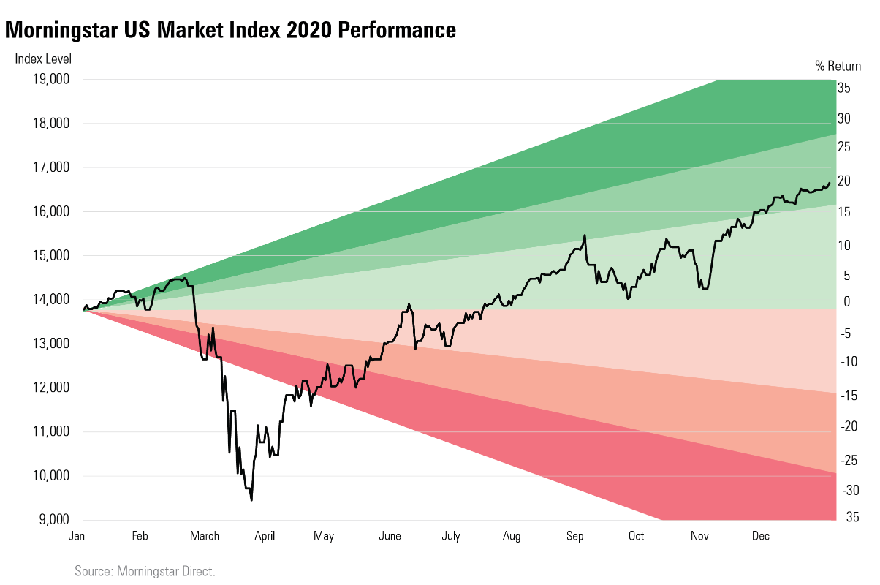

Overall, the performance has ticked positively for most stocks. The growth in some sectors such as technology balanced the losses made in hospitality and travel, with the balance favoring the former. The over-performers currently mostly have higher than normal price-to-earnings ratio, meaning that they may start becoming unattractive at some point.[1]

EFTs are increasingly becoming institutional investors’ index of choice due to their versatility.[2] In the last 10 years, more than 2,000 ETFs have been created and in aggregate, ETFs have accumulated assets of more than $4 trillion and projections that ETF assets could reach $6 trillion by 2020.[3] Simultaneously, flows out of active mutual funds have accelerated dramatically

In selecting our portfolio holdings, we also wanted to recognize how the COVID-19 pandemic has caused a significant impact on the global economy and thus has impacted widespread investment decisions. For example, during the pandemic items such as stimulus checks being sent out influenced an increase in inflation, but low interest rates also redirected choices of investing instruments. With all these considerations in mind, we proceeded with the following strategy.

## Strategy Description

With the currently highly volatile economic scenario, and considering a short-term investment portfolio, our team decided to focus on building a diversified portfolio with less volatile securities. Our investment decision allocates more weights on securities with less volatility while including a small percentage of growth stocks; growth stocks being those companies that are considered to have potential to outperform the overall market over time because of their future potential (even if it is already relatively high) as the companies reach or exceed that potential. Thus, we started with the following choices:

|  |  |  |  |  |
| --- | --- | --- | --- | --- |
| **Stock Symbol** | **Price** | **Share** | **Cost base (IMV)** | **Initial weight** |
| **GOOGL** | $2,507.51  $2,591.59 | 1  6 | 2,517.51  15,559.54 | 18% |
| **TSLA** | $650.21 | 20 | 13,014.2 | 13% |
| **VTWV** | $142.26 | 100 | 14,236 | 14% |
| **VONV** | $69.82 | 270 | 18,861.4 | 19% |
| **ARKG** | $89.88 | 111 | 9,986.68 | 10% |
| **Cash** |  |  |  | 26% |

## Company Analysis

Our decision to invest in Google’s (GOOGL) stock was because of its positive revenue trend from increase in market demand from Google Services which generate revenue primarily from advertising through its wide breadth of platforms as well as sales from in-app purchases, subscription costs and sale of hardware and digital content products. Google has 75% of the internet search market and 85% of the mobile search market which continues to grow as it becomes an integral part of daily life across the world. Google has a large borrowing capacity that allows it to buy out any competitor that may be seen as a serious threat to them and the ubiquity of its search product ensures its continued evolution to deliver better results for users; with the competitive advantage Google has along with its cash reserves it has a beta of 1.03, compared to the smaller competitors which have greater betas at 1.6 on average.

Our interest in Tesla (TSLA) comes from its growth potential. Its current market capitalization of $692 billion makes it the primary market leader by sales as opposed to other automaker such as Ford, sitting at $56.77 billion, Ford producing 9 times more units than Tesla as of 2020 as well. The foundation of Tesla as an edge producer of high value auto and a technology company focusing on non-fossil-based energy make it a target of interest for us. On July 8th, 2021, there were reports that Tesla’s stock would reach the bearish ‘death cross’ where its 50 DMA is set to end a 20-month run above the 200 DMA which could warn of further losses for the stock. As markets opened and progressed no price decreases were observed, thus stockholders hold their position mostly with hope that stock would continue rising.

The Vanguard Russell 2000 Value ETF (VTWV) was chosen when we consider our strategy to minimize our risk by diverting investment to several mutual funds while keeping an eye for opportunities when the economy is more stable to put more weight in single stocks. VTWV does not weight more than 1% so the risk related to individual stocks is limited. There is a common pattern of small-cap value-oriented ETFs observed currently: financials are overweight at 26.80% and technology and healthcare are underweight (less than 6%). Banks represent 15.80% of the fund value. Consumer discretionary and industrials are the second and third heaviest sectors, but their weights are close to the parent index.

The Russell 2000 Value Index (VONV) currently holds 864 stocks. The top 15 holdings represent 21% of the portfolio value and no holding weights more than 3%, so the risk related to any individual stock is quite low. The portfolio is curated by selecting and weighting stocks based on two style factors: price-to-book rations and growth forecasts. VONV reaches beyond the large-cap space to include significant exposure to midcaps. This preference for smaller firms has at times made it slightly riskier, however the fund is likely to lean away from consumer non-cyclical and technology stocks and towards financials. Overall, we see VONV as delivering adequate exposure.

Last, we chose ARKG Genomic Revolution ETF (ARKG). Companies within ARKG are focused on and are expected to substantially benefit from extending and enhancing the quality of life by incorporating technological and scientific development and advancements in genomics into their business. When the federal investment rate is low, we wanted to invest in something that yields higher interest rates but at the same time is safe. We found that ARKG is the most pragmatic choice in this field given our investment strategy.

# STOCK AND MARKET PERFORMANCE ANALYSIS

## Daily Stock Statistics

The following is the daily average return and standard deviation of the stock picks we held from July 2nd, 2021, to August 27th, 2021, including information on the S&P 500.

|  |  |  |
| --- | --- | --- |
| **Company** | **Daily Average Return** | **Standard Deviation** |
| **GOOGL** | 0.0019 | 0.0219 |
| **TESLA** | 0.0068 | 0.0513 |
| **ARKG** | 0.0032 | 0.0305 |
| **RHI** | 0.0014 | 0.02814 |
| **VONV** | 0.00067 | 0.0193 |
| **S&P 500** | 0.0009 | 0.0184 |

Of note is that, initially, we started with VTWV, an ETF, as one of our stock picks. We decided instead to trade for Robert Half, Inc. (RHI) which is an employment placement agency. During this short period of time, we made sure to keep up to date on the news and latest published analyses of market trends and within industries. In doing so we realized that there had been an uptrend in people receiving COVID-19 vaccinations. More vaccinations, in our thoughts, meant more individuals being ready to work and seek employment-- thus higher utilization of employment placement agencies. Based on this, we found it a good idea to invest in an employment agency, and chose Robert Half, Inc. We chose Robert Half, Inc. specifically due to its particularly steady performance to make sure it better evens out on our portfolio when we switch it out for VTWV.

## Capital Asset Pricing Model (CAPM)

Using a 10% significant level

|  |  |  |  |  |  |  |
| --- | --- | --- | --- | --- | --- | --- |
| **Company** | **Alpha** | **Alpha P-Value** | **Alpha Significant?** | **Beta** | **Beta P-Value** | **Beta Significant?** |
| **GOOGL** | 0.0008 | 0.2193 | No | 0.965 | <0.0001 | Yes |
| **TSLA** | 0.0053 | 0.0494 | No | 1.3960 | <0.0001 | Yes |
| **ARKG** | 0.0002 | 0.0849 | Yes | 1.12231 | <0.0001 | Yes |
| **RHI** | 0.0004 | 0.7614 | No | 0.9376 | <0.0001 | Yes |
| **VONV** | -0.0004 | 0.2330 | No | 0.9800 | <0.0001 | Yes |
| **S&P 500** | -0.002 | 0.0477 | Yes | 0.9891 | <0.0001 | Yes |

Although all our stocks contain higher risk than the S&P 500, they also provide a higher return.

## 

## Fama-French 3 Factor Model

|  |  |  |  |  |  |  |  |  |
| --- | --- | --- | --- | --- | --- | --- | --- | --- |
| **Company** | **Alpha** | **Alpha P-value** | **Rm-Rf** | **Rm-Rf P-Value** | **SMB** | **SMB P-Value** | **HML** | **HML P-value** |
| **GOOGL** | 0.0007314 | 0.2384 | 1.01937 | <0.0001 | -0.20328 | 0.0039 | -0.2190 | <0.0001 |
| **TSLA** | 0.00427 | 0.0494 | 1.48009 | <0.0001 | 0.98094 | <0.0001 | -1.18511 | <0.0001 |
| **ARKG** | 0.0008069 | 0.3040 | 1.17608 | <0.0001 | 1.32898 | <0.0001 | -1.24419 | <0.0001 |
| **RHI** | 0.0008909 | 0.3489 | 0.79769 | <0.0001 | 0.00511 | 0.9620 | 0.83747 | <0.0001 |
| **VONV** | -0.000114 | 0.4498 | 0.92024 | <0.0001 | -0.06220 | 0.0003 | 0.40259 | <0.0001 |

## 

The data on the table that are highlighted signify that the associated value is statistically significant in accordance with how the p-value reflects on the estimate based on a 10% significance level. The Fama-French 3 factor model, like the CAPM model, contains analysis of alpha and beta values however it also takes into consideration market risk premium (Rm-Rf, historic excess of returns of a small cap company over large cap companies (SMB: Small Minus Big), as well as historic excess of stocks with a high book-to-price ratio over those with low book-to-price ratios (HML: High Minus Low). Here, we see a difference in alpha significance between the CAPM and FF 3-factor noting that TSLA seems to hold the only significant alpha based on its P-Value. Tesla appears to have the highest market risk compared to the market portfolio. Due to its significant alpha, we note that the TSLA stock is performing well and thus should continue to include this stock in our portfolio.

## Sharpe Ratio

We decided to utilize a 4% acceptable return for the Sharpe and the Safety-First ratio.

|  |  |
| --- | --- |
| **Company** | **Sharpe Ratio** |
| **GOOGL** | 0.1166 |
| **TSLA** | 0.1923 |
| **ARKG** | 0.1426 |
| **RHI** | 0.0722 |
| **VONV** | 0.0460 |
| **S&P 500** | 0.0656 |

## Safety First Ratio

|  |  |
| --- | --- |
| **Company** | **Safety First Ratio** |
| **GOOGL** | 0.1101 |
| **TSLA** | 0.1894 |
| **ARKG** | 0.1380 |
| **RHI** | 0.0667 |
| **VONV** | 0.0388 |
| **S&P 500** | 0.0581 |

GOOGL, TSLA, ARKG, and RHI all have higher Sharpe and Safety-First ratios compared to the S&P 500, meaning their returns will be less than 4% lower than that of the S&P 500 under the assumption that returns are normally distributed.

## Ranking

Overall, 4 out of 5 of the stocks in our portfolio outperform the S&P 500 based on 3 main risks return tradeoff measurements-- coefficient variation, Sharpe ratio, and safety-first ratio. VONV was the only company which consistently underperformed compared to the S&P 500. Utilizing the analysis and comparisons presented thus far of each stock to each other as well as the S&P 500, we then decided on the following ranking from our top pick to our bottom pick.

1. **Tesla**
2. **ARKG Genomic Revolution**
3. **Google**
4. **Robert Half, Inc.**
5. **Russell 2000 Value Index**

# 

# PORTFOLIO OPTIMIZATION

Optimum Portfolio & Asset Allocations

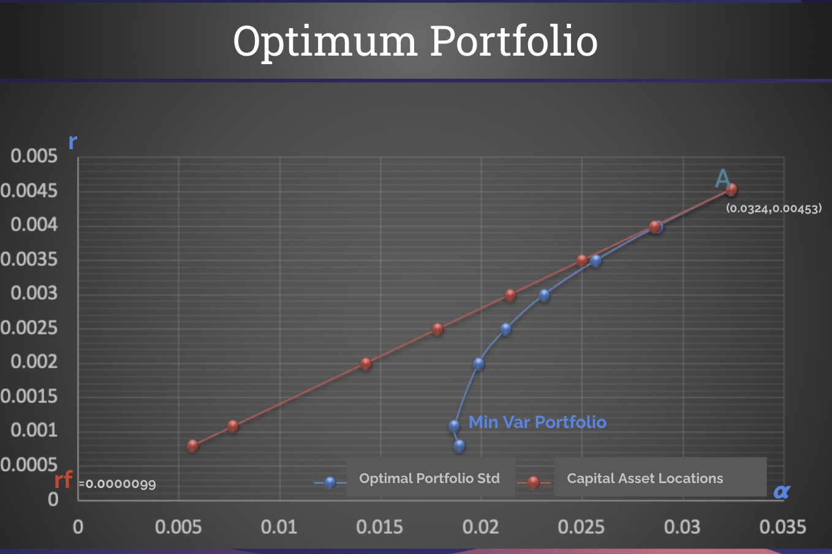

According to the statistical data found from our analyses, the Portfolio daily target return is to be set at 0.00453 with the given risk at 0.0324. This return achieves an optimal Sharpe ratio of .14 which is twice as much as S&P 500 return (.7). The weights are allocated as follows: ​​Tesla takes 47%, ARKG contributes 28%, Google shares 15% and Robert Half carries 10% of the portfolio.

We believe this is a reasonably achievable target because our decision is based on stock historical data, peer to peer performance comparisons, plus industry and market expectation predictions. Our security investment includes a relatively diversified portfolio in which obtains the lowest possible risk. While carefully selecting an optimal combination of securities, we are also actively on the outlook to identify a potential candidate to add to our portfolio for achieving a lower portfolio risk.

# REFLECTION & FINAL THOUGHTS

Building a successful portfolio requires not only technical capability but it also requires continual and extensive research such as industry, market, economy outlooks, etc. From a quantitative aspect, a portfolio manager needs to carry out multiple hypothesis testing using different models for spotting and taking advantage of market anomalies (CAPM, Three Factor Model…), or even develops his own ‘secret’ model to be able to build a high return portfolio.

With the influx of data and information nowadays, keeping up with new information and the ability to acquire, analyze and interpret data in a timely manner are especially important. At the end, however, the essential part of building and maintaining a successful portfolio is to proactively tweak that portfolio to earn greater returns based on the evidence from the quantitative analyses coupled with a wide range of knowledge to support this decision.

# APPENDIX



1. https://www.morganstanley.com/ideas/stock-market-outlook-2021
2. https://www.visualcapitalist.com/the-26-year-history-of-etfs-in-one-infographic/
3. http://www.pionline.com/article/20170131/ONLINE/170139973/the-evolution-of-the-etf-industry